# Architectural Views

**Group members:**

KrishnaSai Reddy Patil

Pranav Jaipurkar

Aman Geetey

Tigist Shibeshi

Yili Zhang

Vijayadhaarani Vijayaarunachalam

**Techno-Tidbits**

Contents

Architectural Views 1

1. Logical View 3

a. Component Diagram 3

b. Package Diagram 4

c. Component and Interface Description 4

I. Component Description 4

II. Interface Description 5

2. Behavior View 6

3. Information View 7

4. Deployment View 8

5. Allocation View 9

Requirements Allocation View: 9

Work Allocation View: 10

# 

# 

# Logical View

## Component Diagram

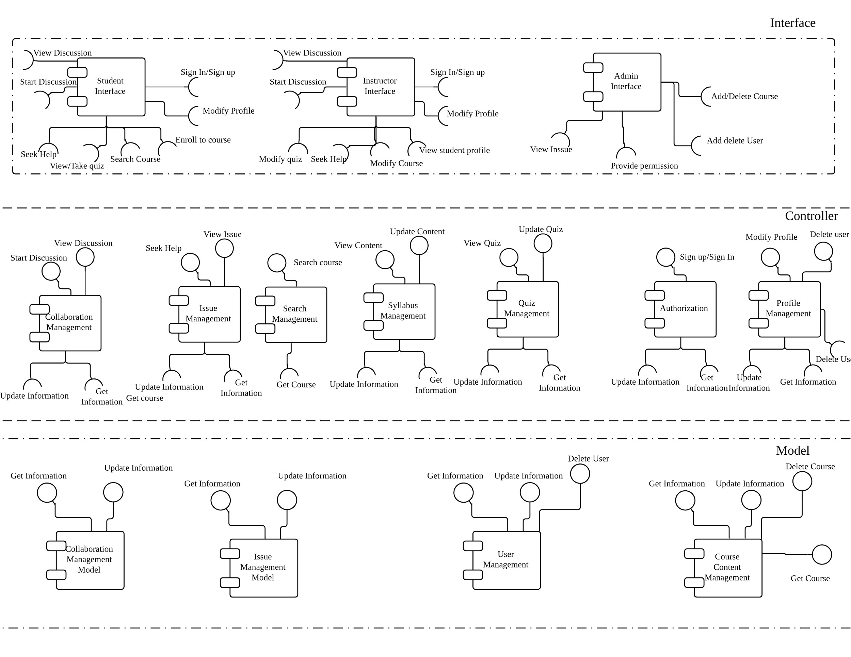

## Package Diagram

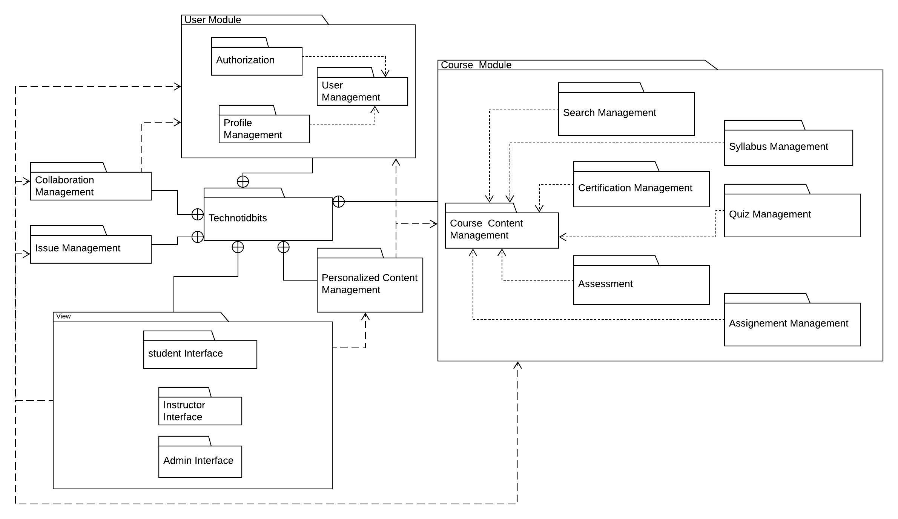

## Component and Interface Description

### Component Description

**Component Name**: Quiz Management

**Component Responsibilities:** Enables the student to view, and take a quiz for the course he/she is enrolled. Enables the instructor to update and view the quiz for the course he/she tutors.

**Provided Interface:** Update Quiz, View Quiz

**Required Interface:** Get Information, Update Information

### Interface Description

* **Interface name**: View Quiz
* **Interface responsibilities**: Interface updates the view with the details of the quiz
* **Interface operations:**

1. Search quiz
   1. Operation Signature : Search quiz( QuizName: String):Boolean
   2. Operation Description : Triggers a search request for the quiz
   3. Operation Preconditions : Quiz data is present in the database
   4. Operation Post conditions : Quiz data is located
2. Get Quiz
   1. Operation Signature : Get quiz( QuizName: String):String
   2. Operation Description : Obtains the quiz data to be displayed
   3. Operation Preconditions : Quiz data is present in the database
   4. Operation Post conditions : Quiz is located and data is obtained
3. Update view
4. Operation Signature : Update View( QuizName: String):String
   1. Operation Description : Quiz data is formatted & view updated
   2. Operation Preconditions : Quiz data is obtained
   3. Operation Post conditions : Interface view is updated with quiz data

# Behavior View

Sequence diagram gives the sequence for student login, searching for a course, enrolling and taking a quiz.

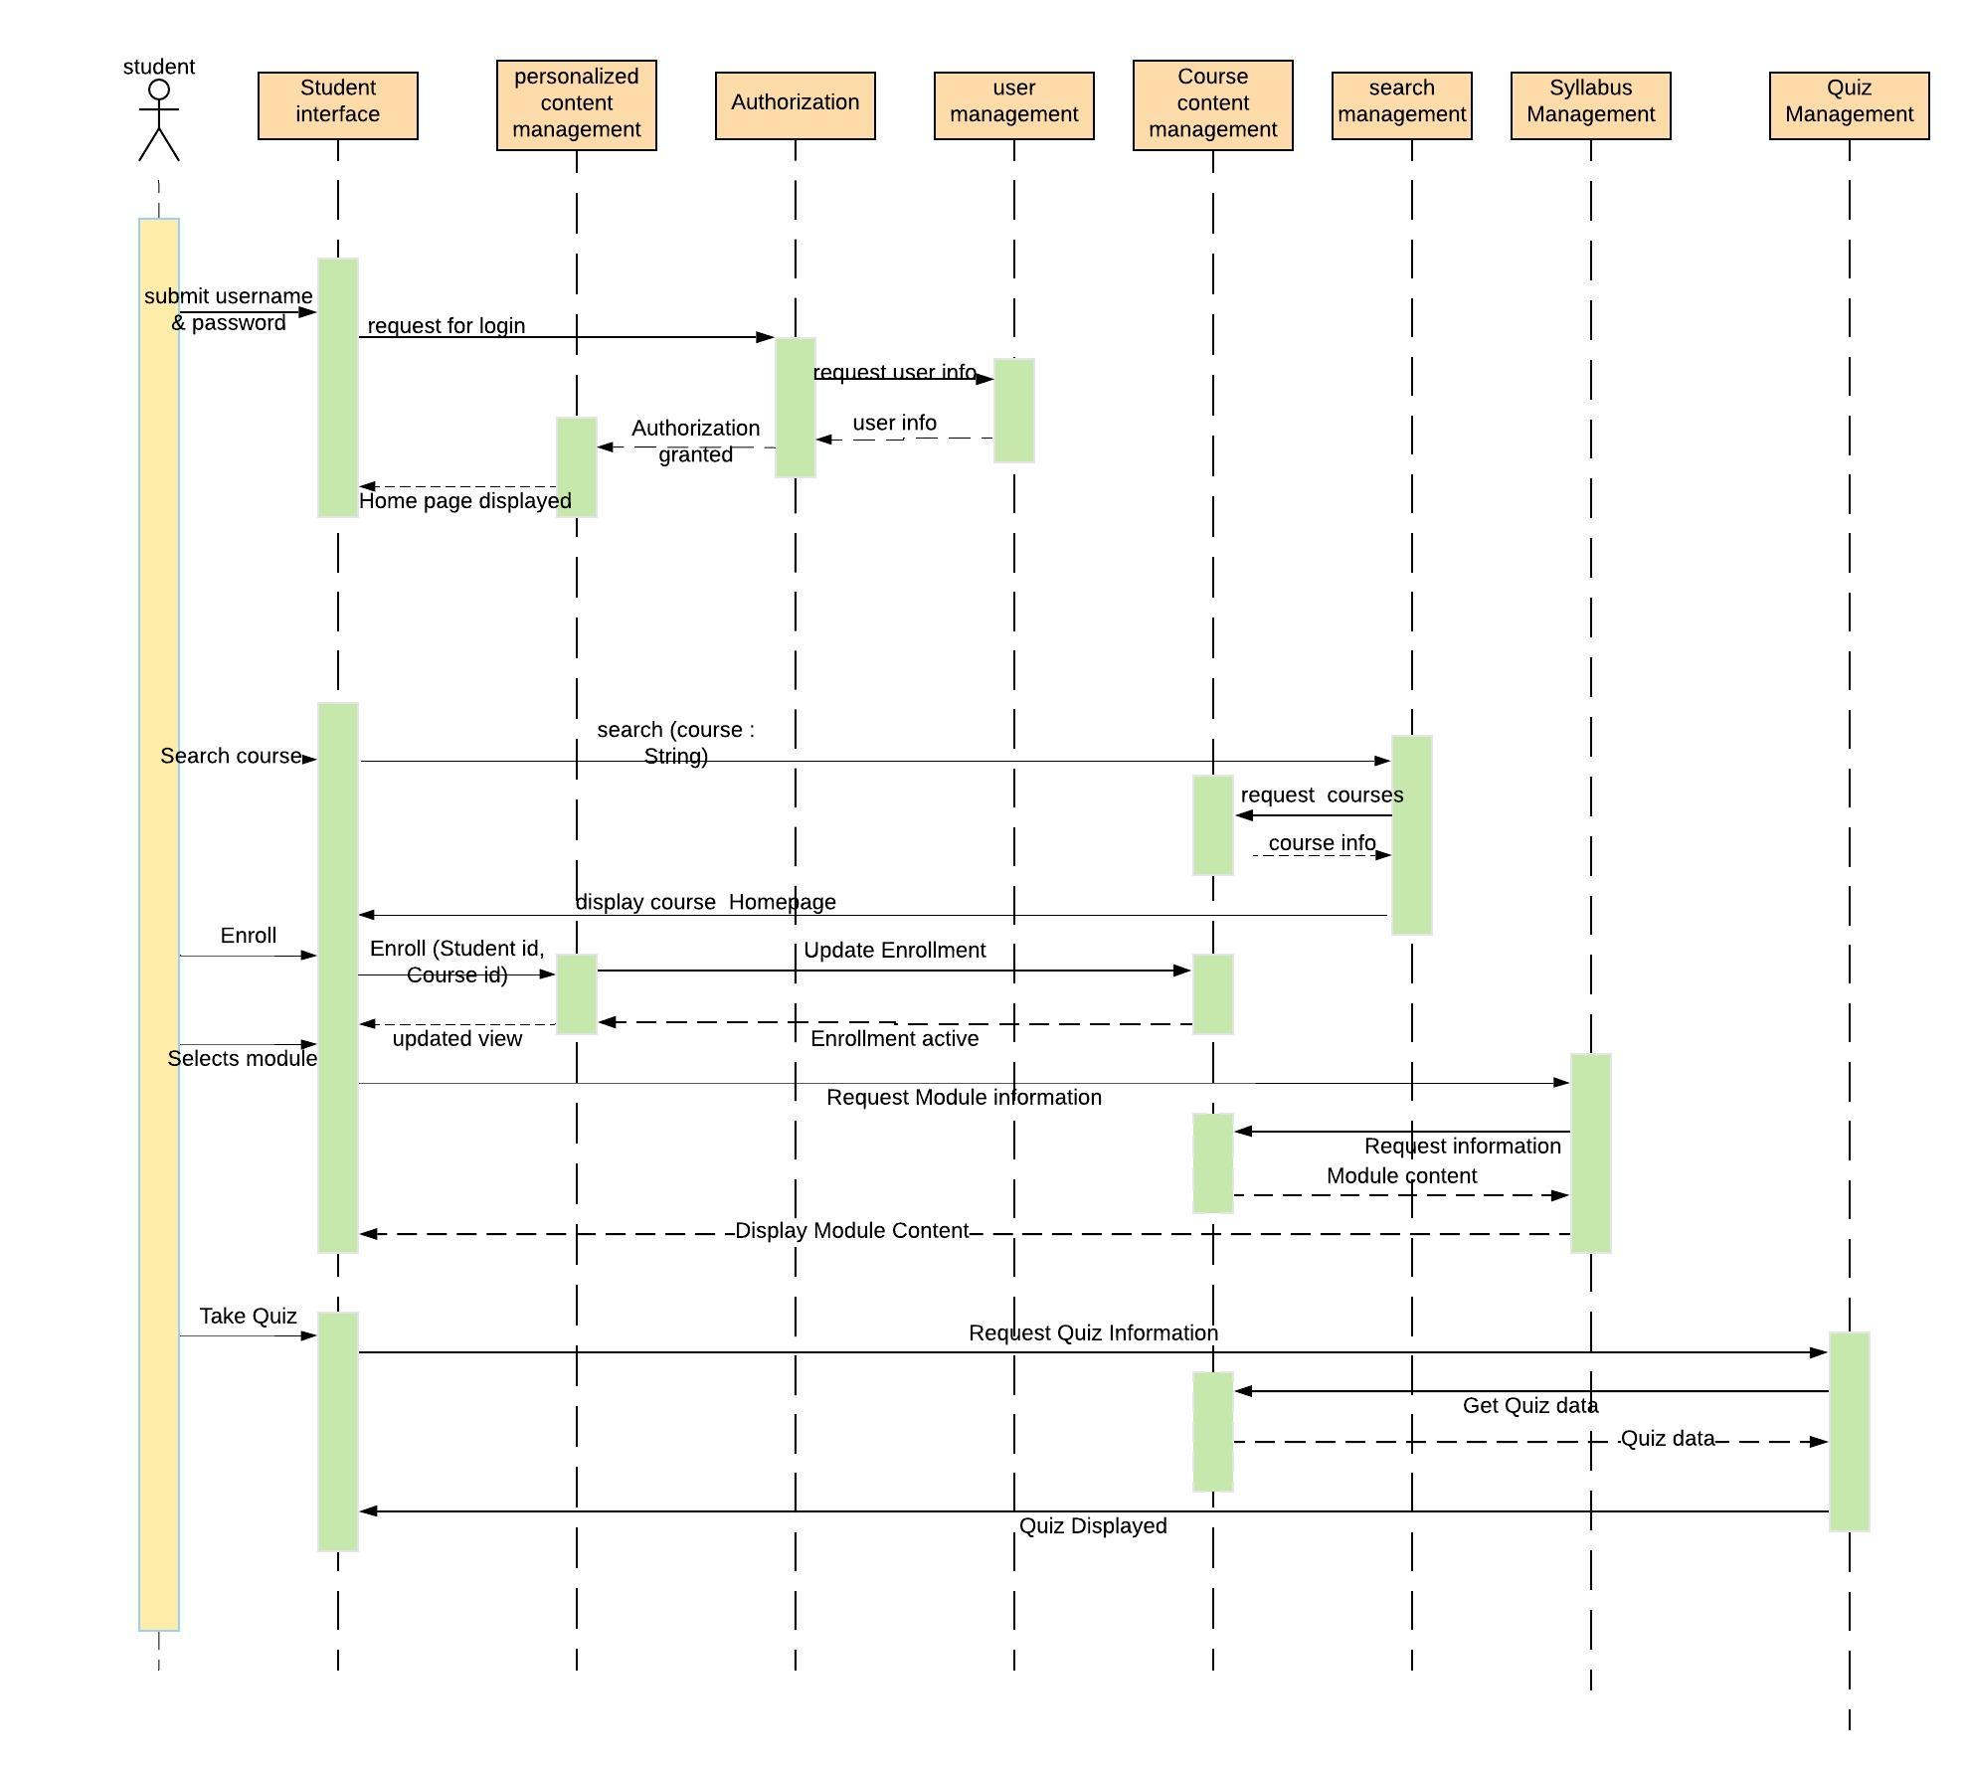

# Information View

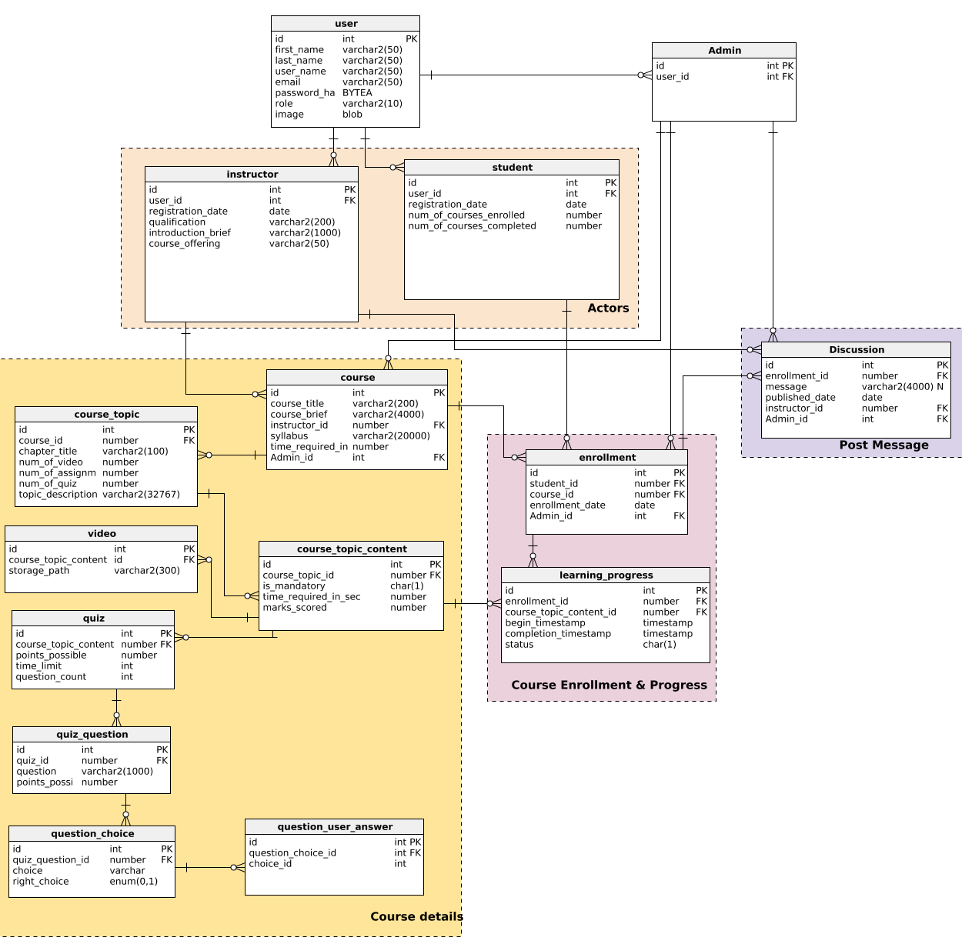

# Deployment View

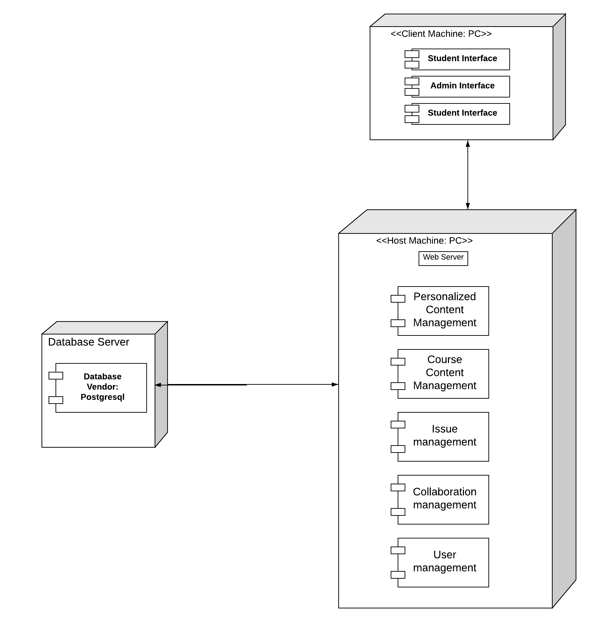

# Allocation View

## Requirements Allocation View:

|  |  |  |  |  |  |
| --- | --- | --- | --- | --- | --- |
| Features Allocation |  |  |  |  |  |
| **Features** | Personalized Content management | Collaboration Management | Course content management | User management | Issue Management |
| Sign in/ Sign up |  |  |  | X |  |
| Modify Profile |  |  |  | X |  |
| See Courses details | X |  | X |  |  |
| Add, drop courses | X |  |  |  |  |
| View dashboard. | X |  |  |  |  |
| Take quiz, exams | X |  | X |  |  |
| View other profiles |  | X |  |  |  |
| Send or receive messages to/from instructor or students. |  | X |  |  |  |
| Seek help from the admin |  |  |  |  | X |
| Seek permission to teach courses | X |  | X |  |  |
| Modify the course content |  |  | X |  |  |
| See all students enrolled in the course. |  | X |  |  |  |
| Create, edit, delete and quiz. |  |  | X |  |  |
| Add, Modify, remove course content, quiz |  |  | X |  |  |
| Grant, Decline permission to teach courses. | X |  | X |  |  |
| Add, delete students. |  |  |  | X |  |
| Add,delete instructors (admin) |  |  |  | X |  |
| Revoke permission to Teach |  |  | X |  | X |

## Work Allocation View:

|  |  |  |  |
| --- | --- | --- | --- |
| Work Allocation |  |  |  |
| Components | Detailed Design | Implementation | Testing |
| Personalized Content management | Dhaarani,pranav | Sai,Aman | Tigist, Yilli |
| Collaboration Management | Pranav,Aman | Dhaarani,Yilli | Tigist,Sai |
| Course content management | Dhaarani,Yilli | Pranav, Yilli,Sai | Tigist,Aman |
| User management | Tigist, Dhaarani | Yilli,Aman | Sai,Pranav |
| Issue Management | Sai,Pranav | Tigist,Aman | Yilli,Dhaarani |